**Antonov AN-32**

*Military knowledge into civil’s applications*

By:

Juan Andrés Bermúdez Gómez

Jeison Fabian Cruz Sanabria

Kevin Andrés Castañeda Acevedo

Juan Esteban Acuña Zambrano

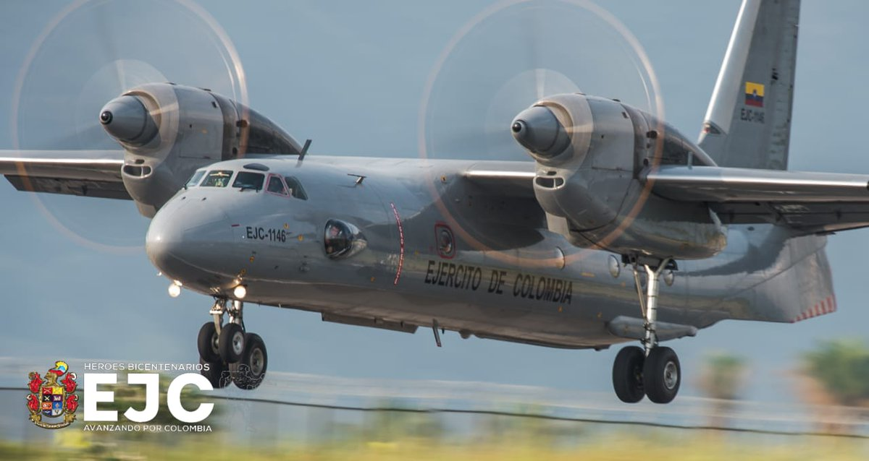

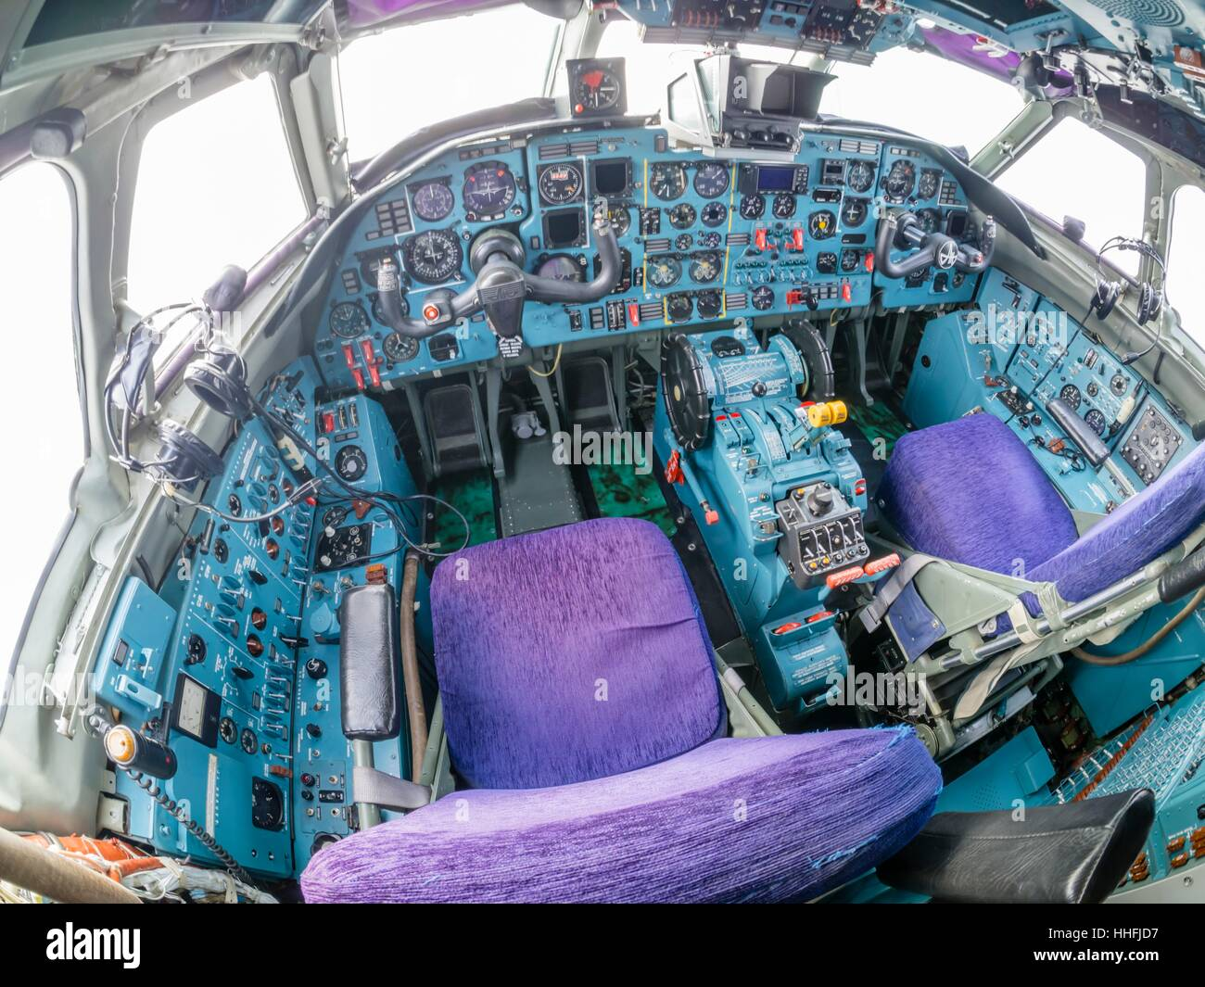

**Specifications of the airplane**

|  |  |  |  |  |  |  |  |  |  |  |  |
| --- | --- | --- | --- | --- | --- | --- | --- | --- | --- | --- | --- |
| **Antonov An-32** | | | | | | | | | | | |
| **Crew** | **Capacity** | **Length** | **Wingspan** | **Height** | **Wing area** | **Empty weight** | **MTOW** | **Maximum speed** | **Cruise speed** | **Range** | **Service ceiling** |
| 4 | 6700 kg | 23,78m | 29,2 m | 8,75 m | 75 m^2 | 16800 kg | 27000 kg | 530 km/h | 470 km/h | 2500 km | 9500 m |
| 4 | 14771 lb | 78 ft 0 in | 95 ft 10 in | 28 ft 8 in | 810 sq ft | 37038 lb | 59525 lb | 330 mph | 290 mph | 1600 mi | 31200 ft |

**Requirements by FAA**

The Federal Aviation Administration (FAA) has a set of requirements established in the Title 14 of the Code of Federal Regulations part 25, also known as the Federal Aviation Regulations (FAR) 25, for the transport category airplanes, setting the airworthiness standards for the aircrafts who satisfies the category.

The Antonov An-32 is a turboprop twin-engined military transport aircraft and due its weight, fits into the FAR 25 and must achieve all the requirements named in the document.

In our project we’ll focus on the pilot’s seat, which must meet certain requirements other than a passage seat. First, we’ll list it:

1. Seat backs proving a 25-pound minimum breakaway force are an acceptable means of compliance.
2. Contact between the head, pelvis, torso or shoulder area of one Anthropomorphic Test Dummy (ATD) with the head, pelvis, torso or shoulder area of the ATD in the adjacent seat is not allowed during the tests conducted in accordance with <https://www.ecfr.gov/current/title-14/chapter-I/subchapter-C/part-25/subpart-C/subject-group-ECFRda24a9b1d389632/section-25.562#p-25.562(b)(1)>. Contact during rebound is allowed.

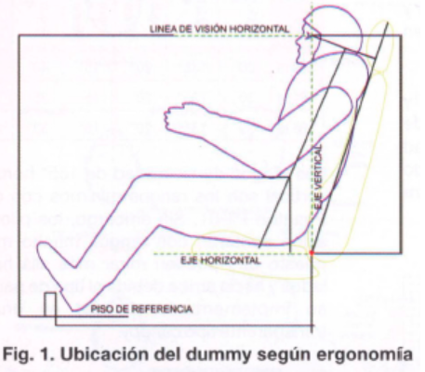

1. Under emergency landing conditions, the seat must meet: upward 3.0g, forward 9.0g, sideward 3.0g on the airframe and 4.0g on the seats and their attachments, downward 6.0g, rearward 1.5g.
2. Each occupant must be protected from serious head injury under the conditions prescribed in <https://www.ecfr.gov/current/title-14/chapter-I/subchapter-C/part-25/subpart-C/subject-group-ECFRda24a9b1d389632/section-25.562#p-25.562(b)>. Where head contact with seats or other structure can occur, protection must be provided so that the head impact does not exceed a Head Injury Criterion (HIC) of 1,000 units. The level of HIC is defined by the equation:

1. Where leg injuries may result from contact with seats or other structure, protection must be provided to prevent axially compressive loads exceeding 2,250 pounds in each femur.
2. The windshield panels in front of the pilots must be arranged so that, assuming the loss of vision through any one panel, one or more panels remain available for use by a pilot seated at a pilot station to permit continued safe flight and landing.

1. Each occupant of a seat that makes more than an 18-degree angle with the vertical plane containing the airplane centerline must be protected from head injury by a safety belt and an energy absorbing rest that will support the arms, shoulders, head, and spine, or by a safety belt and shoulder harness that will prevent the head from contacting any injurious object. Each occupant of any other seat must be protected from head injury by a safety belt and, as appropriate to the type, location, and angle of facing of each seat, by one or more of the following: A shoulder harness that will prevent the head from contacting any injurious object, The elimination of any injurious object within striking radius of the head, An energy absorbing rest that will support the arms, shoulders, head, and spine.
2. Each seat or berth, and its supporting structure, and each safety belt or harness and its anchorage must be designed for an occupant weight of 170 pounds, considering the maximum load factors, inertia forces, and reactions among the occupant, seat, safety belt, and harness for each relevant flight and ground load condition.
3. Each pilot seat must be designed for the reactions resulting from the application of the pilot forces prescribed in <https://www.ecfr.gov/current/title-14/chapter-I/subchapter-C/part-25/subpart-C/subject-group-ECFR9d800e4222ac84e/section-25.395>.
4. The inertia forces specified in <https://www.ecfr.gov/current/title-14/chapter-I/subchapter-C/part-25/subpart-C/subject-group-ECFRda24a9b1d389632/section-25.561> must be multiplied by a factor of 1.33 (instead of the fitting factor prescribed in <https://www.ecfr.gov/current/title-14/chapter-I/subchapter-C/part-25/subpart-D/subject-group-ECFRff93ea3edba9270/section-25.625>) in determining the strength of the attachment of each seat to the structure and each belt or harness to the seat or structure.
5. Each forward observer's seat required by the operating rules must be shown to be suitable for use in conducting the necessary enroute inspection.

**Client’s requirements:**

1. Better materials, satisfying the FAA’s requirements.
2. Capability of all axis movements for better adjustment of views and perspectives.
3. An update of the design and innovation of the pilot’s seat in an aircraft from the last siècle.